BIOC 404
March 20th 2006

Principles of Magnetic Resonance Imaging (MRI)

The topic of today’s lecture is magnetic resonance imaging (MRI), a medical imaging technique based on NMR. In fact it is NMR but the name was changed to MRI because the term “nuclear” unfortunately tends to scare “scientifically challenged” people while MRI is emotionally neutral. Using the same principles that we have studied in the last few lectures, it is possible to obtain high-resolution images of any part of the body in a non-invasive and non-radioactive way.

How does it work? It is actually fairly simple! It is based on the fact that water has different concentration depending on the tissue in the body. For example water concentration will be slightly higher for cerebrospinal fluid in the brain than white or gray matter.

The technique can be easily understood if we imagine a sample that is empty except for two cylinders of water at different position along the x-axis. If this sample is put in a magnetic field without gradient, only one peak is obtained after the Fourier transform is done since both cylinders feel the same magnetic field and thus have the same resonant frequency. However, if this sample is put in a magnetic field with a gradient along the x-axis, then there will be 2 peaks after Fourier transform since the resonant frequency is proportional to the magnetic field and both cylinder of water are in fields of different intensity. This gives us a 1D map of the sample because we can deduce the local magnetic field from the peak frequency. Since the field gradient is known, we can get the position of both cylinders on the x-axis. We can also have an idea of the concentration of water for each by the intensity of the peaks.

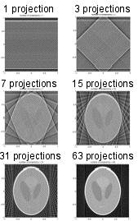
To get a 2D map, the same experiment has to be repeated along different axes to give multiple projections. For example, a gradient along the x-axis can be done first, then along the y-axis, then a mix of both x and y axis etc. The results of each projection are added up by a mathematical process called Radon transformation (similar to Fourier transform) to give a 2D map of the sample. As shown in the figure on the right, the resolution increases with the number of projection. This is the basic principles on how mapping is done but other properties of proton, such as spin-lattice and spin-spin relaxation, can be used to enhance contrast of the image.

Spin-lattice relaxation

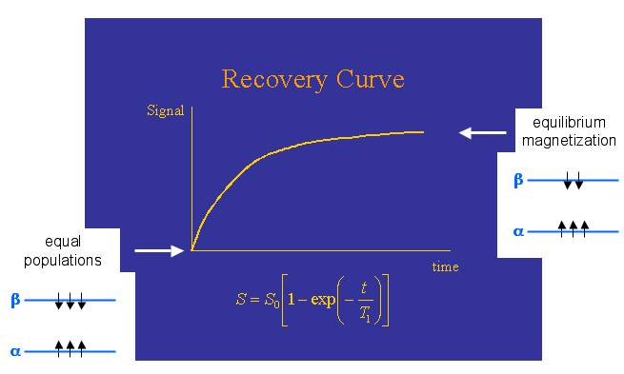
As seen in earlier lectures, the magnetization on the z axis relaxes back to I^{Z} exponentially with a time constant of T1 (the reciprocal of R1, which is the relaxation rate) according to Bloch’s equation. Right after a pulse hit a sample, the population of both spin states are exactly the same. However, it goes back to equilibrium state along I^{Z}, which has a slight preference for the low-energy state with spin parallel to the magnetic field, with a time constant T1. Therefore, when a MRI experiment is run, a certain time delay has to be observed between projections (90^{Y} pulse) so that magnetization grows back on the z-axis toward equilibrium.

When the first MRI experiments were done, they tried varying the time in between pulses and what they found was that contrast was higher when t=0. Since there is a higher contrast, it means that magnetization of water recovers at different rate depending on the tissue; so T1 of water is tissue specific. This effect can be clearly seen on the slide below; the contrast is higher at 0s than at any other times. In this case it would appear that water from white matter recovers faster than water from gray matter because at short delay there is more signal. The contrast is the same for all other delays, which means that after 3 seconds the magnetization reached equilibrium in all tissues and therefore there is no increased contrast due to difference in T1.

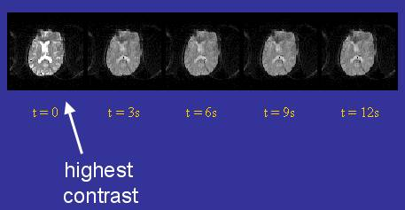

Inversion recovery method

It is possible to enhance contrast even more efficiently by a method called Inversion recovery which inverse magnetization. This method is used in chemistry to measure T1 of protons. The pulse sequence is fairly simple: 180^{Y} pulse brings magnetization on –I^{Z}, a time delay Δ allows magnetization to relax back toward Iz (spin-lattice relaxation) and then a 90^{Y} pulse puts magnetization along I^{X} (positive if magnetization along z-axis was positive and negative if it was negative on the z-axis at the time of the 90^{Y} pulse). The second pulse is necessary because, as we saw before, signal in NMR is measured on the xy plane and not on the z-axis.

We can consider 2 scenarios: Δ=0 and Δ=very long. If Δ=0, the 180^{Y} sequence put magnetization along –I^{Z}, the (nonexistent) Δ won’t change magnetization and the 90^{Y} pulse switch it to –I^{X} (you can ensure that this is correct by doing the hand trick, but if you are in the library I suggest you try to be subtle because people might think you are weird). In the case of Δ = very long, the 180^{Y} sequence put magnetization along –I^{Z}, the magnetization will relax back to I^{Z} due to spin-lattice relaxation and the 90^{Y} pulse put magnetization along I^{X}. We can see that at very small time delay, the signal will be negative, as delay increases it will pass through zero and then become positive.

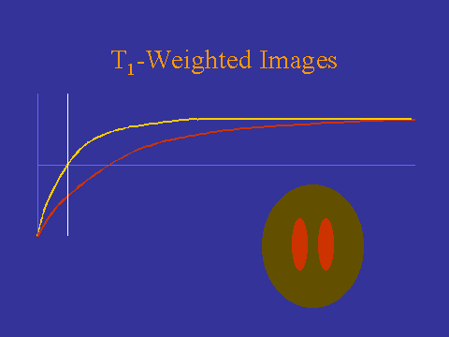
By doing this experiment at various Δ, it is possible to obtain T1. The formula for the final magnetization along the x-axis is: 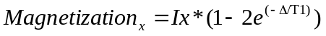. This means that Magnetization_{x}=0 when 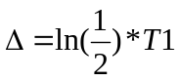. Since T1 in various tissues are known, it is possible to use a time delay that cancel out I^{X} magnetization of a single tissue. For example in the figure below on the left, there is no yellow signal from the surrounding tissue while there is negative signal from the red tissue while on the right there is a positive signal from the surrounding yellow tissue but no red signal. Using inversion recovery method it is thus possible to know precisely which tissue is being map and remove a tissue from the image.
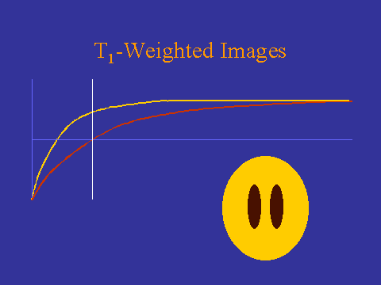

Spin-spin relaxation

There are also other types of MRI experiments which measure spin-spin relaxation rates. Dr Gehring mentioned that he was not an expert on MRI so that he didn’t know when they’re used exactly but some images are based on T2 measurement. Transverse (spin-spin) relaxation is driven by small fluctuations in magnetic field experienced by different nuclei. This changes the rotation rate of these nuclei so that some will rotate slightly faster or slower which tends to spread out magnetization along the xy plane. This tends to reduce magnetization in the xy plane to zero. This return to equilibrium is also governed by the Bloch equation, dependant on T2 (called the spin-spin or transverse relaxation time). As we saw before, long T2 gives sharper signal because it takes longer for spin to get out of sync, which allows more time to acquire free induction decay (FID) signal. One of the big problems with the experiments that measure T2 in MRI is that since several projections need to be taken to get a good resolution, it can be a very lengthy process if equilibrium has to be reached between every measurement. Indeed, the normal way to measure T2 is to do a 90 degree pulse on a sample at equilibrium and then look at the decay of the signal on the xy plane, wait until magnetization reaches equilibrium on the z-axis and start over again. One way to make the process faster is to use the spin echo method.

Spin echo sequence

This pulse sequence is simply a way to refocus procession in the xy plane without having to wait for the signal to relax back on the I^{Z} axis. First, a 90^{Y} pulse is done to bring magnetization from I^{Z} to I^{X} (not shown in sequence below because it’s not technically part of spin echo, it is just needed to put magnetization on x at first). Then there is a wait time t during which nuclei with omega>0 rotate counterclockwise and nuclei with omega<0 rotate in a clockwise direction. A 180^{X} pulse then flip the xy plane so that nuclei that rotate counterclockwise are now clockwise compared to I^{X} and nuclei that rotate clockwise are counterclockwise compared to I^{x}. This means that the nuclei that are not exactly on I^{X} now rotate toward I^{X} instead of away from it. After a second delay t, the signal should be perfectly refocused on I^{X}. I suggest you try to understand the sequence both conceptually and know how to derive it with trigonometry as Dr Gehring spent some time going over it.

To get a MRI image, only one 90^{Y} pulse has to be done and then spin echo can be used to refocus magnetization in the xy plane along I^{X} in between different field gradient projections. This allows an approximately 60-fold reduction in time needed to get enough projections to get a high-resolution image.

